VCE Loudoun Master Gardener Composting Basics

Composting is a great way to recycle your lawn, leaf, tree clippings and kitchen waste. Finished compost may be used as an amendment for garden soil, as mulch around the base of plants, or as a rich planting medium.

- Step 1: Selecting a Site
  - Locate in a convenient place
  - Situate away from nearby tree roots
  - Locate in an area that gets full sun
  - Keep within range of the hose

- Step 2: Building a Compost Pile
  - Create a series of layers to speed up the process of decomposition.
  - Alternate green and brown layers until you have a pile that is 6 to 8 inches high
  - For best results use 60% Carbon (brown material) 40% Nitrogen (green materials)

- Step 3: Add Green (nitrogen) or Wet materials
  - Green to Include:
    - Fresh grass clippings
    - Shrub and tree trimmings
    - Weeds, vegetation and old fruits and vegetables
    - Coffee grounds
  - Green layer should be two to four inches thick

- Step 4: Add Brown (carbon) or Dry materials
  - Brown materials include:
    - Dried grass clippings
    - Dead leaves and pine needles
    - Wood chips
    - Shredded paper
  - Brown layer should also be about two to four inches thick.
  - Chop or shred materials if necessary to speed up the decomposing process

- Step 5: Add Finished compost or soil
  - Periodically add a spade of rich soil to increase microorganisms - this will speed up the decay process
  - Do not add fertilizer; amend the soil per instructions from soil test

- Step 6: Add Water
  - Maintain a moisture content of 60 to 70 percent in the pile - it helps the microbes multiply
  - Add water until the composting feels like a damp sponge

- Maintenance
  - Check the temperature inside the pile every week or so. LCMG compost bin boasts temperatures of 160 degrees in the middle of the pile.
  - Turn the pile inside out by digging down into the center of the pile and bringing the inside material to the outside until well mixed. Break up any large clumps of material.
  - Add water
  - Repeat this process every time the temperature drops
  - When the temperature of the pile won't rise above 110 degrees the compost is finished

- “Black Gold”
  - The finished compost is dark, crumbly and earthy smelling
  - A well-maintained compost pile that contains shredded materials and is turned and watered regularly will be ready in about six to eight months
  - Use as an amendment for garden soil, as a mulch around the base of plants or as a rich planting medium
www.loudouncountymastergardeners.org
Revised 4/26
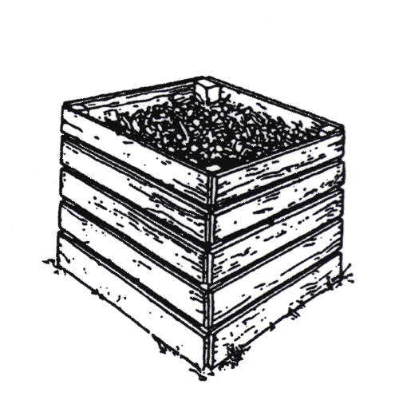 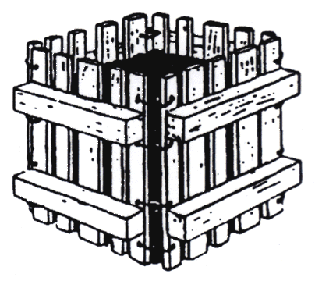
Wooden Pallet Unit
Single Wooden Unit

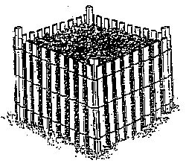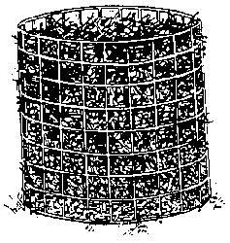
Hardware Cloth Unit
Snow Fence Bin

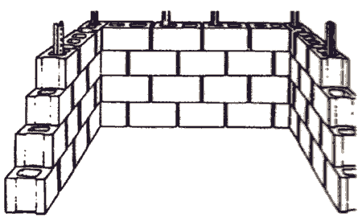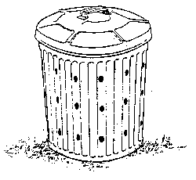
Drum/Trash Can Unit
Cement Block Bin

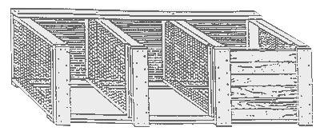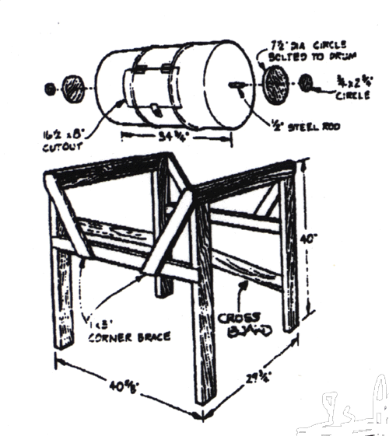
Wood & Wire 3 Bin Turning Unit
Rotating Barrel Composter

